Design and Development of a Project Recommendation System based on Profile Complementarity
School of Computer Science and Engineering, UNSW Sydney
Chief Investigator: Dr. Sonit Singh
Co-Investigators: Dr. Basem Suleiman, Dr. Aditya Joshi

Problem Statement
Group project allocation in CSE courses currently relies on manual assessment and subjective decision-making, leading to skill mismatches and team dysfunctions. Students struggle to identify projects matching their collective skillset, while teaching staff face administrative overhead in managing team formations and project assignments.

Project Objective
Develop an AI-powered recommendation system that matches student teams to projects by analyzing skill complementarity. The system will extract skills from resumes and project descriptions, normalize them using the Australian Skills Classification (ASC) framework, and recommend optimal project-team pairings using hybrid algorithms.

Technical Approach

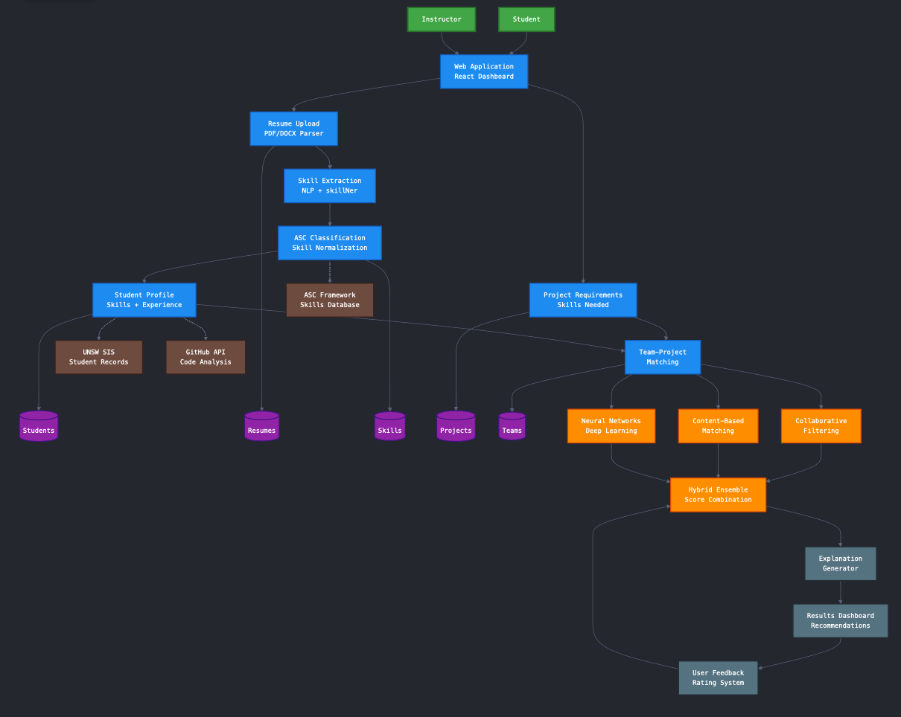

1. Skill Extraction Pipeline
Resume Processing:
- Document parsing: pdfplumber, python-docx for multi-format support (PDF, DOCX, TXT)
- NLP processing: spaCy 3.x with custom trained NER models for academic context
- Skill extraction: skillNer library combined with transformer-based models
- Text embeddings: sentence-transformers (all-MiniLM-L6-v2) for semantic skill matching
Project Analysis:
- Parse project descriptions to extract required technical and soft skills
- Map project requirements to ASC skill categories
- Weight skills by importance using TF-IDF and domain-specific heuristics

2. Skill Normalization
- Framework: Australian Skills Classification (ASC) for standardized skill mapping
- Taxonomy: Map extracted skills to ASC hierarchy (Level 1: Broad categories → Level 5: Specific skills)
- Synonym handling: Custom dictionary + semantic similarity (cosine similarity >0.85 threshold)
- Proficiency inference: Rule-based scoring (1-5 scale) based on contextual cues from resumes

3. Profile Aggregation
- Individual profiles: Structured representation of student skills with proficiency levels
- Team profile: Aggregate function combining individual skills, handling overlaps and complementarities
- Gap analysis: Identify missing critical skills for each project

4. Recommendation Engine
Hybrid Architecture:
- Content-based filtering: Cosine similarity between team skill embeddings and project requirement embeddings
- Collaborative filtering: Matrix factorization (scikit-learn's NMF) on historical project-team success data
- Neural component: PyTorch-based feedforward network (3-layer MLP) for pattern learning
- Ensemble: Weighted combination (60% content-based, 25% collaborative, 15% neural)
Explainability:
- LIME (Local Interpretable Model-agnostic Explanations) for recommendation reasoning
- Skill gap visualization showing missing vs. covered requirements

Technology Stack

Backend
- Framework: FastAPI (Python 3.10+)
- Database: PostgreSQL 14 (structured data), Redis (caching)
- Search: Elasticsearch 8.x for full-text skill search

ML/NLP Libraries
- Core NLP: spaCy 3.7, skillNer, Transformers (Hugging Face)
- ML: scikit-learn 1.3 (NMF, clustering), PyTorch 2.0
- Embeddings: sentence-transformers, FAISS for vector similarity search
- Evaluation: MLflow for experiment tracking

Frontend
- Framework: React.js 18 with TypeScript
- UI: Tailwind CSS, Chart.js for skill visualizations
- State management: React Query

Infrastructure
- Containerization: Docker, Docker Compose
- CI/CD: GitHub Actions
- Deployment: AWS (EC2, S3, RDS) or Azure equivalent

Implementation Timeline (4-5 Months)
Month 1: Resume processing pipeline (pdfplumber, spaCy NER, skillNer integration)
Month 2: ASC framework integration, skill normalization, profile generation
Month 3: Recommendation algorithms (content-based, collaborative, neural hybrid)
Month 4: Web application (FastAPI backend, React frontend, PostgreSQL setup)
Month 5: Pilot evaluation in CSE courses, performance optimization, paper writing

Evaluation Metrics
- Skill extraction: Precision, Recall, F1-score (manual annotation baseline)
- ASC mapping accuracy: % correctly classified to ASC taxonomy
- Recommendation quality: NDCG@10, MAP, user satisfaction surveys
- System performance: API response time (<500ms), throughput (100+ concurrent users)

System Features

Student Portal
1. Authentication & Profile Setup
- UNSW zID authentication and email verification
- Profile creation wizard (personal info, academic details, WAM/GPA)
- Profile completion progress indicator
2. Resume & Skills Management
- Resume upload (PDF/DOCX/TXT) with auto-extraction using spaCy and skillNer
- Manual skill editing with proficiency levels (1-5 scale)
- Skill categories: Technical, Programming, Soft Skills, Domain Knowledge
- GitHub/LinkedIn profile integration
- Skills imported from completed CSE courses
3. Project Discovery
- Browse projects with detailed descriptions and skill requirements
- Search and filter by technology stack, difficulty level, industry domain
- Project match scores with explainable AI reasoning (LIME-based)
- Sort by popularity, match score, or deadline
4. Team Formation & Matching
- AI-recommended teammates based on skill complementarity
- Team creation, invitation, and application system
- Team profile visualization (skill radar charts using Chart.js)
- Browse existing teams looking for members
5. Communication & Collaboration
- In-team messaging system
- Email and in-app notifications (team invites, deadlines, updates)
- File sharing and meeting coordination
6. Project Management & Progress
- Project milestone tracking
- Deliverable submission with version control
- Individual task assignment and completion
7. Feedback & Evaluation
- Peer evaluation and rating system
- Anonymous peer assessment tools
- Self-reflection forms
8. Analytics & Insights
- Personal skill development tracking over time
- Project participation history
- Competency gap identification with learning recommendations
- Career pathway suggestions

Admin Portal
1. User Management
- Bulk student import from UNSW SIS
- Role-based access control (Student, Instructor, Tutor, Assessor, Admin)
- Account administration and zID authentication integration
- Student enrollment tracking and capacity monitoring
2. Course & Project Administration
- Course creation with enrollment limits and academic calendar integration
- Project repository management with approval workflow
- Assessment rubric configuration and grading criteria setup
- Multiple instructor/assessor assignment
3. System Configuration
- UNSW SIS/Moodle/Canvas integration settings
- ASC framework administration and custom skill taxonomy management
- Platform settings (notification templates, file upload limits, security policies)
4. Content Management
- Project template library with versioning
- Resource management (software licenses, cloud services)
- System announcement scheduling and email templates
- Communication audit trails
5. Analytics & Reporting
- System performance monitoring (API response times, user activity)
- Academic analytics (enrollment stats, success rates, team formation metrics)
- Skill development trends across cohorts
- Compliance reporting (GDPR/Privacy Act, audit logs)

Innovation & Differentiation
- Academic focus: Unlike corporate tools (LinkedIn Skills, VIVA), designed specifically for educational project workflows
- ASC standardization: First system to leverage Australian Skills Classification in academic team formation
- Hybrid AI: Combines statistical, semantic, and neural approaches with explainable outputs
- Automated extraction: Eliminates manual skill tagging through resume parsing and NLP
- Dual portal architecture: Separate optimized interfaces for students (engagement) and admins (management)
Admin
Random allocation
Number of students
SKILL SET LEVEL
DUMMY USERS
SKILL ATTRIVUTES

